VOLUNTEER ROLE DESCRIPTION 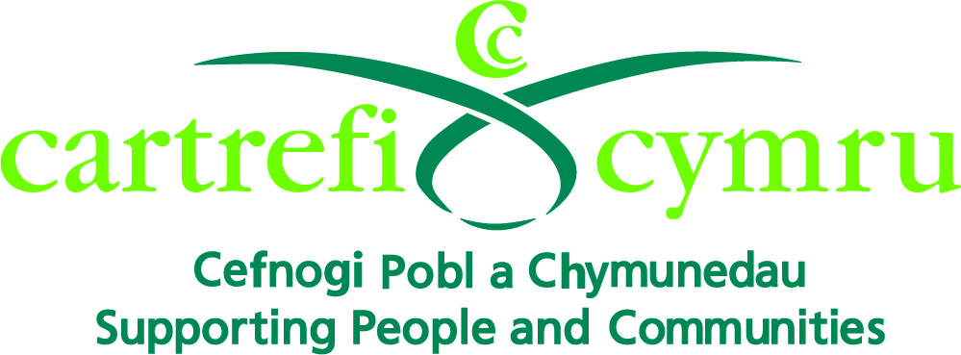

Organisation Name: | Cartrefi Cymru
Volunteer Role Title: | STAR C.I.C Volunteer
Aim of the Volunteer Programme: | To set up a network of volunteers to enable the people we support with learning disabilities in Bridgend to maximise their independence through playing an active part in their communities.
Volunteer responsible to: | Volunteer Coordinator
Volunteer Role Location: | Brackla Industrial Estate, Bridgend
Main Purpose of Volunteer Role: | To help within the community to enable the participants to access Social Enterprise activities to enable them to:  - Fulfil their potential  - Develop new skills  - Make new friends  - Create opportunities  - Make choices  - Increase self-confidence  - Be more independent
Types of Volunteering Tasks | - Helping supported people gain working skills through activities  - Teaching customer service skills  - Teaching reception skills
Main Responsibilities of the Volunteer: | - Support vulnerable adults in the specified Centre  - Assist in the activities taking place within the Centre  - Promote a person centred environment by listening to individuals with sensitivity to their needs  - Promote new opportunities for the participants through sharing your knowledge and skills  - Promote independence with the people we support e.g. encourage them to do things for themselves  - Support other volunteers and work as a team  - Familiarise yourself with and support Cartrefi Cymru’s ethos, policies and procedures as stated in the Volunteer Induction Handbook  - Attend mandatory training and any other training deemed to be appropriate  - Attend supervision and reviews  - Support health and safety within the Centre by having an awareness of the surrounding environment for yourself, the people we support, staff and other volunteers  - Promote equality and diversity as specified in the Volunteer Induction Handbook  - Respect confidentiality at all times  - Use Cartrefi Cymru’s Safe and Sound System with each visit

