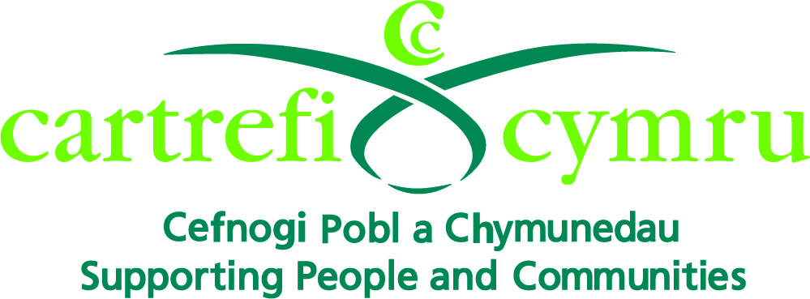

VOLUNTEER ROLE DESCRIPTION

Organisation Name: | Cartrefi Cymru
Volunteer Role Title: | One-to-one Befriender
Aim of the Volunteer Programme: | To set up a network of Volunteers to enable the people we support with learning disabilities in Bridgend to maximise their independence through playing an active part in their communities.
Volunteer responsible to: | Volunteer Coordinator
Volunteer Role Location: | Pre-arranged locations within Bridgend county
Main Purpose of Volunteer Role: | To participate within the community to enable the people we support to access community activities to enable them to:  - Fulfil their potential  - Develop new skills  - Make new friends  - Create opportunities  - Make choices  - Increase self-confidence  - Be more independent
Types of Volunteering Tasks | - Listening and chatting  - Watching a DVD  - Cooking in the befriendee’s home  - Gardening  - Going for a walk  - Going shopping  - Going for a meal  - Going to the cinema  - Sporting activities
Main Responsibilities of the Volunteer: | - Support people with learning disabilities in a pre-arranged location  - Respect Cartrefi Cymu’s support staff in the befriendee’s home when visiting or carrying out activities  - Promote a person centred environment by listening to individuals with sensitivity to their needs  - Encourage new opportunities for the people we support e.g. through sharing hobbies and interests  - Promote independence with the people we support e.g. encourage them to do things for themselves  - Support other volunteers and work as a team when applicable  - Familiarise yourself with and support Cartrefi Cymru’s ethos, policies and procedures as stated in the Volunteer Induction Handbook  - Attend mandatory training and any other training deemed to be appropriate  - Attend supervision and reviews  - Support health and safety within the supported person’s home and any other location visited with the befriendee, by having an awareness of the surrounding environment for yourself, the people we support, staff, other volunteers and the public  - Promote equality and diversity as specified in the Volunteer Induction Handbook  - Respect confidentiality at all times  - Use Cartrefi Cymru’s Safe and Sound System with each visit

