VOLUNTEER ROLE DESCRIPTION 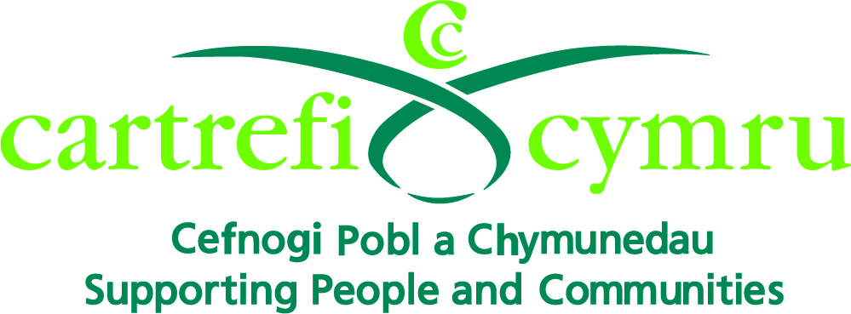

Organisation Name: | Cartrefi Cymru
Volunteer Role Title: | Activity Group-based Volunteer
Aim of the Volunteer Programme: | To set up a network of Volunteers to enable the people we support with learning disabilities in Bridgend to maximise their independence through playing an active part in their communities.
Volunteer responsible to: | Volunteer Coordinator
Volunteer Role Location: | Specified Centre(s) within Bridgend county
Main Purpose of Volunteer Role: | To participate within the community to enable the people we support to access community activities to enable them to:  - Fulfil their potential  - Develop new skills  - Make new friends  - Create opportunities  - Make choices  - Increase self-confidence  - Be more independent
Types of Volunteering Tasks | - Listening and chatting  - Going for a walk  - Arts and crafts  - Singing  - Playing bingo  - Helping the supported person to make a cup of tea
Main Responsibilities of the Volunteer: | - Support people with learning disabilities in a specified Centre  - Assist support staff in the smooth running of the Centre activities  - Assist in the activities taking place within the Centre  - Promote a person centred environment by listening to individuals with sensitivity to their needs  - Promote new opportunities for the people we support e.g. through sharing hobbies and interests  - Promote independence with the people we support e.g. encourage them to do things for themselves  - Support other volunteers and work as a team  - Familiarise yourself with and support Cartrefi Cymru’s ethos, policies and procedures as stated in the Volunteer Induction Handbook  - Attend mandatory training and any other training deemed to be appropriate  - Attend supervision and reviews  - Support health and safety within the Centre by having an awareness of the surrounding environment for yourself, the people we support, staff and other volunteers  - Promote equality and diversity as specified in the Volunteer Induction Handbook  - Respect confidentiality at all times  - Use Cartrefi Cymru’s Safe and Sound System with each visit

