VOLUNTEER ROLE DESCRIPTION 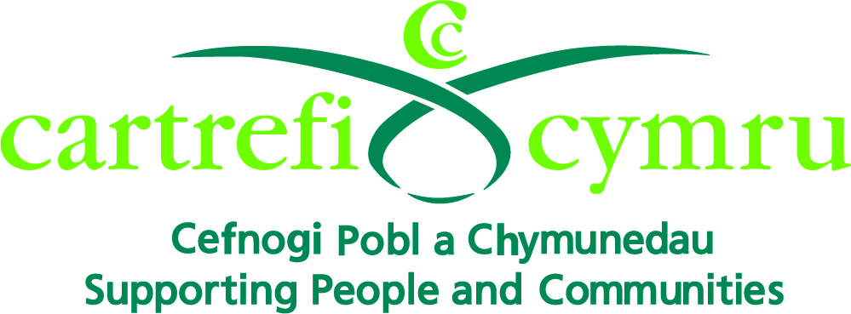

Organisation Name: | Cartrefi Cymru
Volunteer Role Title: | Allotment Volunteer
Aim of the Volunteer Programme: | To set up a network of volunteers to enable the people we support with learning disabilities in Bridgend to maximise their independence through playing an active part in their communities.
Volunteer responsible to: | Volunteer Coordinator
Volunteer Role Location: | Cartrefi Cymru Allotment, Badgers Brook, Brackla, Bridgend
Main Purpose of Volunteer Role: | To participate within the community to enable the people we support to access community activities to enable them to:  - Fulfil their potential  - Develop new skills  - Make new friends  - Create opportunities  - Make choices  - Increase self-confidence  - Be more independent
Types of Volunteering Tasks | - Listening and chatting  - Digging  - Weeding  - Planting  - Woodwork  - Minor construction activities  - Helping and interacting with service users  - Helping with activities
Main Responsibilities of the Volunteer: | - Support people with learning disabilities in a pre-arranged location  - Assist Cartrefi Cymu’s staff, the people we support and other volunteers in activities taking place at the allotment  - Promote a person centred environment by listening to individuals with sensitivity to their needs  - Encourage new opportunities for the people we support e.g. through sharing hobbies and interests  - Promote independence with the people we support e.g. encourage them to do things for themselves  - Support other volunteers and work as a team when applicable  - Familiarise yourself with and support Cartrefi Cymru’s ethos, policies and procedures as stated in the Volunteer Induction Handbook  - Attend mandatory training and any other training deemed to be appropriate  - Attend supervision and reviews  - Support health and safety within the allotment, by having an awareness of the surrounding environment for yourself, the people we support, staff, other volunteers and the public  - Promote equality and diversity as specified in the Volunteer Induction Handbook  - Respect confidentiality at all times  - Use Cartrefi Cymru’s Safe and Sound System with each visit

